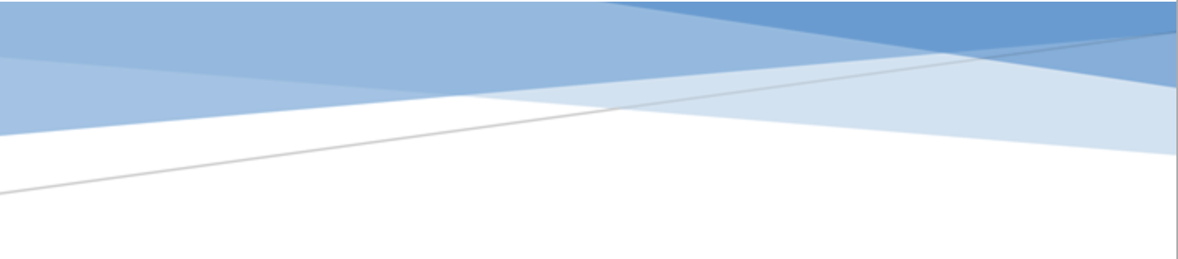



adges UI components library

**Component ID #1 – ex-media-library - v1.0.0**

## Document Control

## Version History

|  |  |  |  |
| --- | --- | --- | --- |
| Version | Date | Author | Reason for Change |
| **1.0.0** | 2019-11-10 | Mahmoud |  |
| **1.1.0** | 2020-24-09 | Rijin Mukundan |  |
|  |  |  |  |
|  |  |  |  |
|  |  |  |  |
|  |  |  |  |
|  |  |  |  |
|  |  |  |  |

## Review History

|  |  |  |
| --- | --- | --- |
| Version | Reviewer | Date |
|  |  |  |
|  |  |  |
|  |  |  |
|  |  |  |
|  |  |  |
|  |  |  |
|  |  |  |

Table of Contents

Document Control 2

Version History 2

Review History 2

1. Document and components Purpose. 4
2. How to use. 5
3. Component features and configure. 6
4. How to configure component. 7
5. Examples 7

# 

# Document and components Purpose.

The purpose of the document is to guide how use and configure [Media Library Listing] component.

The purpose of the Media Library Listing is to List Albums inside page also show the featured video for that album

General Information.

Component Name: Media-library.

Extension Theme: ex-media-library.

Owner: Mahmoud.

Version no: v1.0.0

Design

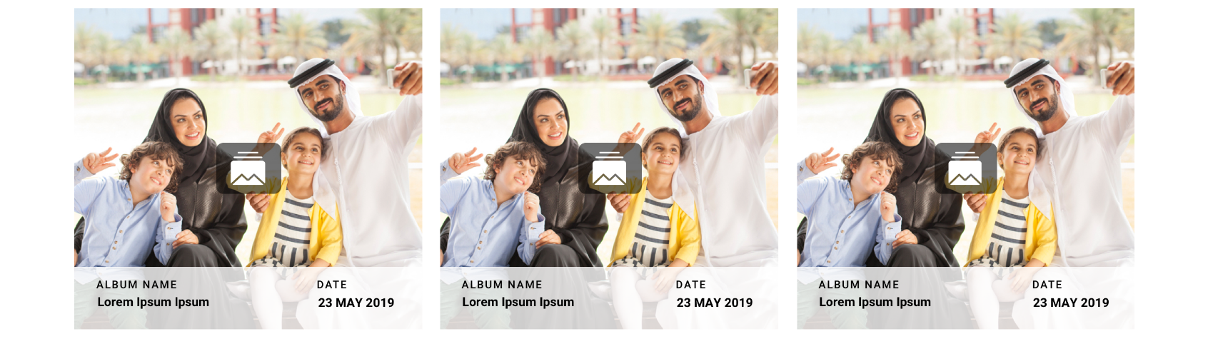

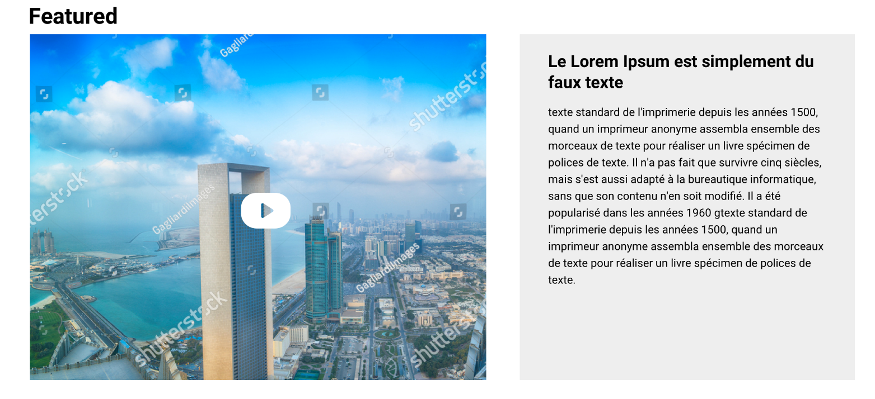

# How to use.

1. The available commands for this project .
   1. Compile : npm run gulp compile -- –path ex-media-library –extension
   2. Compile & include under ADGE tenant : npm run gulp compile -- –path ex-media-library –extension –full –dest [ADGEFolder]
   3. Deploy : npm run gulp deploy -- –path ex-media-library –extension
2. *Now project have full copy from this extension theme under the project theme and you can apply the project brand guideline and configure component based on project needs.*

# Component features and configure.

You have access now to configure component with the below item.

|  |  |  |
| --- | --- | --- |
| **Feature** | **Variable** | **Default value** |
| Anchor color | $media-library-anchor-color | #000 |
| **Media library container height** | $media-library-container-height | 360px |
| **Media library description bottom value** | $media-library-description-bottom-val | 0 |
| **Media Library description bottom value** | $media-library-description-bg | rgba(255, 255, 255, 0.5) |
| **Media Library Description width** | $media-library-description-width | 100% |
| **Media Library Description padding** | $media-library-description-padding | 10px 25px |
| **Media Library description position** | $media-library-description-pos | 0 |
| **Media Library Album font size** | $media-library-album-name-fs | 12px |
| **Media Library icon colo** | $media-library-icon-color | rgba(0, 0, 0, 0.5) |
| **Media Library icon padding** | $media-library-icon-padding | 10px |
| **Media Library icon border radius** | $media-library-icon-border-radius | 10px |
| **Media Library icon font size** | $media-library-icon-fs | 3 rem |
| **Media Library icon background** | $media-library-icon-bg | fff |
| **Media Library featured video height** | $media-library-featured-video-height | 500px |
| **Media Library Featured video icon font size** | $media-library-featured-video-icon-fs | 5rem |
| **Media Library Featured Video icon color** | $media-library-featured-video-icon-color | #fff |
| **Media Library Featured Video**  **Content section background** | $media-library-featured-video-icon-conent-bg | #EEEEEE |
| **Media Library Featured Video**  **Content section height** | $media-library-featured-video-icon-conent-height | 500px |
| **media-library-description-bg** | **$media-library-description-bg** | **rgba(255, 255, 255, 0.5)** |
| **media-library-description-color** | **$media-library-description-color** | **$black-color** |

# How to configure component.

There are various ways to configure the component:

1. **Adding Built-In or Bootstrap Class (on the variant)**
   1. Spaces, Font weights, Display, Position properties etc can be added by bootstrap classes
      1. i. Spacing: <https://getbootstrap.com/docs/4.0/utilities/spacing/>
      2. ii. Flex: <https://getbootstrap.com/docs/4.4/utilities/flex/>
      3. iii. Font: <https://getbootstrap.com/docs/4.0/content/typography/>
   2. These classes should only be added to match the design
   3. For built-in classes check 7 Below to see the entire list
2. **SCSS Variable Override (on the _override.scss file)**

To configure the component we can take the above variables from section **4. Component features and configure** and add them to: adge-ph2/themes/<ADGE>/vars/_override.scss, this file with your desired changes to match the design.

1. **Complete style override**
   1. This should be the last and final option if the above 3 didn’t get you the desired output
   2. This is overwriting the SCSS of the component by adding your own style to it
   3. **Note: Take permission before doing this override**
   4. Instructions:
      1. Open the file /adge-ph2/themes/<ADGE>/sass/overrides.scss and add your own SCSS styles to override the faulty component.

# Dependencies

* components-media-library.css
* jquery-fancybox-min.js
* fancybox-init.js
* components-media-library.js

# Examples

Examples1:

I need to change text color.

I’ll copy the below variables from extension theme.

$highlight-main-tittle-color: $primary-color;

Then will paste the above variable in project folder theme in file _custom.scss and change with any variable based on site needs.

$highlight-main-tittle-color: $secondary-color;

Examples2:

I need to the button shape from square to had a rounded corner.  
I’ll copy the below variables from extension theme.

$button-shape-square: $border-radius-value;

$border-radius-value: 0px;

Then will paste the a above variable in project folder theme in file _custom.scss and change with any variable based on site needs.

$button-shape-square: $border-radius-value;

$border-radius-value: 20px;